GEIRFA NADOLIG

Nadolig | Christmas
Coeden Nadolig | Christmas tree
  Hosan/au | 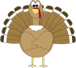  A sock/stocking
Carw / Ceirw | Reindeer
Addurn/iadau | Decoration/s
Carolau | Carol/s
Uchelwydd | Mistletoe
Angel / Angylion | 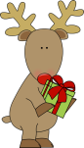  Angel/s
Corrach /Corachod | Elf//elves
Cannwyll | A candle
Anrheg/ion | Present/s
Robin Goch | Robin redbreast
Dyn Eira | A snowman
Siôn Corn | Father Christmas
Pwdin ’Dolig | Christmas Pudding
  Eira | Snow
Twrci | Turkey
Cloch / Clychau |   Bell/s
Doethion | Wise men
Bugeiliaid | Shepherds
Preseb | A manger
Golau / Goleuadau | Light/s
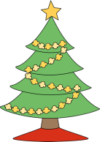  Dyn Sunsur | A gingerbread man
Nadolig Llawen | Merry Christmas
