Mynediad 2: gwers 1 a 2

DECHRAU | Sut dach chi? | Dw i’n byw | Lle dach chi’n byw? | ond
Remember to count the spaces yn Gymraeg! |  |  |  | Pwy dach chi?
Esgusodwch fi | Ffordd | os gwelwch yn dda | Bore da | Wedi blino
ym  Mhrestatyn | 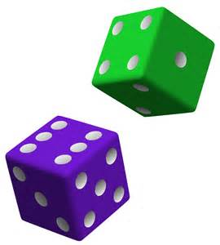  Rholiwch y deis – Roll the dice
Noswaith  dda | Be’di’ch cyfeiriad chi? | A chithau? | Ddim yn ddrwg | ger  yn ymyl  wrth
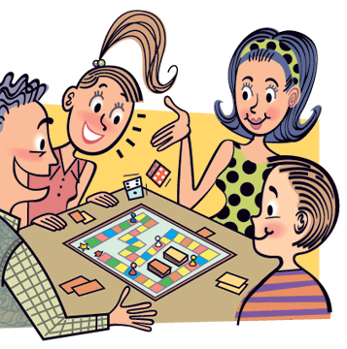  Eich tro chi = your turn (formal)  Dy dro di = your turn (informal) |  |  |  | Llanelwy
Yr Wyddgrug | Be’di...yn Gymraeg? | un deg chwech | Be’di’ch enw chi? | Bendigedig
bore’ma | Daria! Dw i wedi colli. = Drat! I’ve lost
yn lle? | Penarlâg | hwyl | Diolch yn fawr | wela i chi
  Hwre! Dw i wedi ennill = Hooray! I’ve won |  |  |  | GORFFEN
Mynediad 2: gwers 1 a 2

DECHRAU | How are  you? | I live | Where do  you live? | but
Remember to count the spaces yn Gymraeg! |  |  |  | Who are you?
Excuse me | Road | Please | Good  morning | Tired
in Prestatyn | Rholiwch y deis – Roll the dice
Good evening | What’s your  address? | And yourself? | Not bad | by, near to
Eich tro chi = your turn (formal)  Dy dro di = your turn (informal) |  |  |  | St. Asaph
Mold | What is...  in Welsh? | 16 | What’s your  name? | Marvellous
this morning | Daria! Dw i wedi colli. = Drat! I’ve lost
where  exactly? | Hawarden | bye | Thank you  very much | See you.
  Hwre! Dw i wedi ennill = Hooray! I’ve won! |  |  |  | GORFFEN

