

Ysgrifennu Creadigol
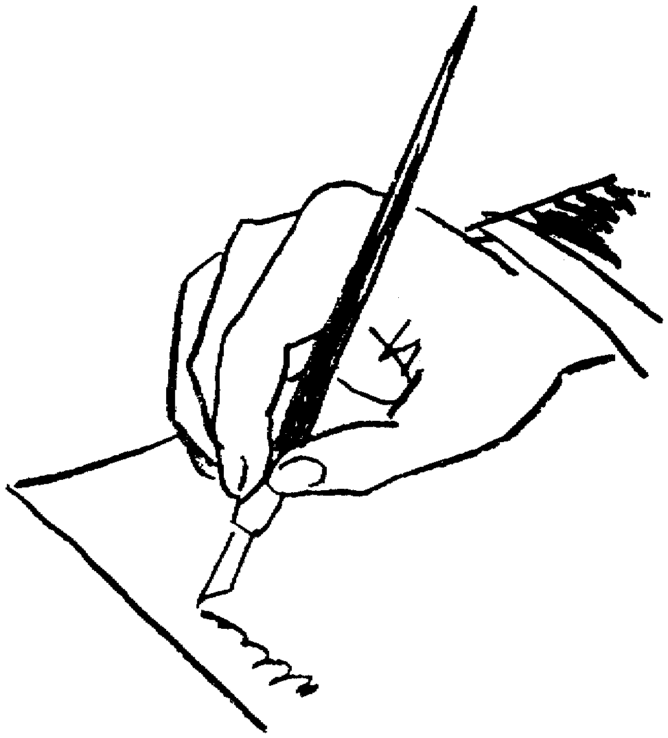

1. Dach chi wedi herwgipio’ch tiwtor. Ysgrifennwch nodyn at Popeth Cymraeg yn gofyn am pridwerth (ransom).
Geirfa berthnasol:
Os na byddwch chi’n .....
Mae gennych chi ... i ymateb.
gwystl

....................................................................................................
....................................................................................................
....................................................................................................
....................................................................................................
....................................................................................................
....................................................................................................
....................................................................................................
....................................................................................................
....................................................................................................
....................................................................................................
....................................................................................................
....................................................................................................
....................................................................................................
....................................................................................................
....................................................................................................
....................................................................................................

2. Mae eich ffrind yn eich ffonio i ddweud ei bod hi wedi’ch gweld yn set gefn car yr heddlu ddoe. Beth ddigwyddodd?
Geirfa berthnasol:
Camddealltwriaeth
Nid fi wnaeth
Mi ges i fy arestio ar gam.
Fi wnaeth o

....................................................................................................
....................................................................................................
....................................................................................................
....................................................................................................
....................................................................................................
....................................................................................................
....................................................................................................
....................................................................................................
....................................................................................................
....................................................................................................
....................................................................................................
....................................................................................................
....................................................................................................
....................................................................................................
....................................................................................................
....................................................................................................

3. Ysgrifennwch olygfa sy’n cychwyn efo’r geiriau ‘dyna oedd y tro cyntaf i mi ladd dyn.’
Geirfa berthnasol:
haeddu
anfwriadol
bwriadol
difaru/edfarhau/edifar/diedifar

....................................................................................................
....................................................................................................
....................................................................................................
....................................................................................................
....................................................................................................
....................................................................................................
....................................................................................................
....................................................................................................
....................................................................................................
....................................................................................................
....................................................................................................
....................................................................................................
....................................................................................................
....................................................................................................
....................................................................................................
....................................................................................................

4. Chi ydi Marilyn Monroe ar fin canu ‘Pen-blwydd Hapus’ i John F. Kennedy. Ysgrifennwch eich teimladau.
Geirfa berthnasol:

....................................................................................................
....................................................................................................
....................................................................................................
....................................................................................................
....................................................................................................
....................................................................................................
....................................................................................................
....................................................................................................
....................................................................................................
....................................................................................................
....................................................................................................
....................................................................................................
....................................................................................................
....................................................................................................
....................................................................................................
....................................................................................................
....................................................................................................


5. Dach chi wrthi’n cael pryd o fwyd efo ffrind. Mae’r ffrind yn cael galwad ffôn. Ysgrifennwch hanner eich ffrind o’r sgwrs.

....................................................................................................
....................................................................................................
....................................................................................................
....................................................................................................
....................................................................................................
....................................................................................................
....................................................................................................
....................................................................................................
....................................................................................................
....................................................................................................
....................................................................................................
....................................................................................................
....................................................................................................
....................................................................................................
....................................................................................................
....................................................................................................

6. Dach chi’n dwyllwr o wlad dramor. Ysgrifennwch ebost i geisio perswadio rhywun i roi £200 i chi.
Geirfa berthnasol:
perthnasau
etifedd
plant truenus
blaendal
cynllun di-ffael

....................................................................................................
....................................................................................................
....................................................................................................
....................................................................................................
....................................................................................................
....................................................................................................
....................................................................................................
....................................................................................................
....................................................................................................
....................................................................................................
....................................................................................................
....................................................................................................
....................................................................................................
....................................................................................................
....................................................................................................

7. Disgrifiwch ogla drwg, ac o lle mae o wedi dod.
Geirfa berthnasol:
drewi
drewdod
pydru
pydredd

....................................................................................................
....................................................................................................
....................................................................................................
....................................................................................................
....................................................................................................
....................................................................................................
....................................................................................................
....................................................................................................
....................................................................................................
....................................................................................................
....................................................................................................
....................................................................................................
....................................................................................................
....................................................................................................
....................................................................................................
....................................................................................................
....................................................................................................

8. Y ffotograff dach chi’n ei drysori fwya’.

Geirfa berthnasol:
achlysur

....................................................................................................
....................................................................................................
....................................................................................................
....................................................................................................
....................................................................................................
....................................................................................................
....................................................................................................
....................................................................................................
....................................................................................................
....................................................................................................
....................................................................................................
....................................................................................................
....................................................................................................
....................................................................................................
....................................................................................................
....................................................................................................
9. Ysgrifennwch hanes eich bywyd fel cyfres o gardiau post.

....................................................................................................
....................................................................................................
....................................................................................................
....................................................................................................
....................................................................................................
....................................................................................................
....................................................................................................
....................................................................................................
....................................................................................................
....................................................................................................
....................................................................................................
....................................................................................................
....................................................................................................
....................................................................................................
....................................................................................................
....................................................................................................
....................................................................................................
....................................................................................................

10. Dach chi’n deffro mewn cae yn gwisgo gwisgo gofodwr ac yn gorwedd ar fwrdd brigonni. Beth ddigwyddodd?

Geirfa berthnasol:
hollol amlwg

....................................................................................................
....................................................................................................
....................................................................................................
....................................................................................................
....................................................................................................
....................................................................................................
....................................................................................................
....................................................................................................
....................................................................................................
....................................................................................................
....................................................................................................
....................................................................................................
....................................................................................................
....................................................................................................
....................................................................................................
....................................................................................................
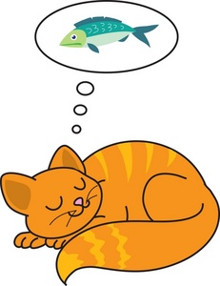
11. Breuddwyd eich anifail anwes.
Geirfa berthnasol:

....................................................................................................
....................................................................................................
....................................................................................................
....................................................................................................
....................................................................................................
....................................................................................................
....................................................................................................
....................................................................................................
....................................................................................................
....................................................................................................
....................................................................................................
....................................................................................................
....................................................................................................
....................................................................................................
....................................................................................................
....................................................................................................
....................................................................................................
12. Ysgrifennwch ddisgrifiad ohonoch chi’ch hun ar gyfer safle dod o hyd i gymar.

....................................................................................................
....................................................................................................
....................................................................................................
....................................................................................................
....................................................................................................
....................................................................................................
....................................................................................................
....................................................................................................
....................................................................................................
....................................................................................................
....................................................................................................
....................................................................................................
....................................................................................................
....................................................................................................
....................................................................................................
13. Ceisiwch berswadio plentyn 4 oed i beidio ag ofni’r tywyllwch.

Geirfa berthnasol:
dychymyg
dychmygol
dewr

....................................................................................................
....................................................................................................
....................................................................................................
....................................................................................................
....................................................................................................
....................................................................................................
....................................................................................................
....................................................................................................
....................................................................................................
....................................................................................................
....................................................................................................
....................................................................................................
....................................................................................................
....................................................................................................
....................................................................................................
....................................................................................................
....................................................................................................
....................................................................................................

14. Dydi dwy bunt ddim yn llawer, oni bai ...

....................................................................................................
....................................................................................................
....................................................................................................
....................................................................................................
....................................................................................................
....................................................................................................
....................................................................................................
....................................................................................................
....................................................................................................
....................................................................................................
....................................................................................................
....................................................................................................
....................................................................................................
....................................................................................................
....................................................................................................
....................................................................................................
....................................................................................................
....................................................................................................

15. Penwythnos yn St. Tropez.
Geirfa berthnasol:
torheulo
pleserlong/iot
coctel
....................................................................................................
....................................................................................................
....................................................................................................
....................................................................................................
....................................................................................................
....................................................................................................
....................................................................................................
....................................................................................................
....................................................................................................
....................................................................................................
....................................................................................................
....................................................................................................
....................................................................................................
....................................................................................................
....................................................................................................
....................................................................................................
....................................................................................................
....................................................................................................

16. Ysgrifennwch stori arswyd i ddychryn plant mewn parti pyjamas.
Geirfa berthnasol:
....................................................................................................
....................................................................................................
....................................................................................................
....................................................................................................
....................................................................................................
....................................................................................................
....................................................................................................
....................................................................................................
....................................................................................................
....................................................................................................
....................................................................................................
....................................................................................................
....................................................................................................
....................................................................................................
....................................................................................................
....................................................................................................
....................................................................................................
....................................................................................................
....................................................................................................

17. Ysgrifennwch lythyr diolch am rywbeth doeddech chi ddim yn ei hoffi o gwbl.
Geirfa berthnasol:
syndod
meddylgar
gwerthfawrogi
delfrydol

....................................................................................................
....................................................................................................
....................................................................................................
....................................................................................................
....................................................................................................
....................................................................................................
....................................................................................................
....................................................................................................
....................................................................................................
....................................................................................................
....................................................................................................
....................................................................................................
....................................................................................................
....................................................................................................
....................................................................................................
....................................................................................................
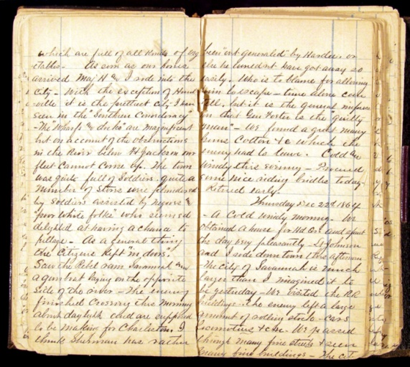
18. Dach chi wedi dod o hyd i ddyddiadur eich hen-hen-nain. Ar 16 Mehefin 1856 ysgrifennodd hi....
Geirfa berthnasol:

....................................................................................................
....................................................................................................
....................................................................................................
....................................................................................................
....................................................................................................
....................................................................................................
....................................................................................................
....................................................................................................
....................................................................................................
....................................................................................................
....................................................................................................
....................................................................................................
....................................................................................................
....................................................................................................
....................................................................................................
....................................................................................................
....................................................................................................
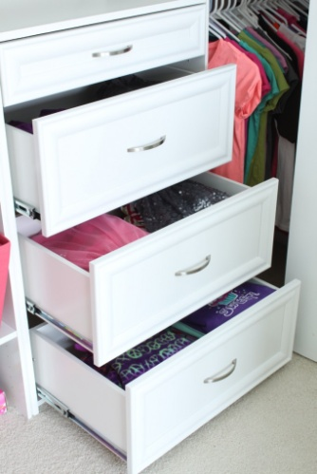
19. Dach chi’n cerdded i mewn i’ch llofft i weld rhywun yn mynd trwy’ch droriau chi.
Geirfa berthnasol:
eiddo
torri’r gyfraith

....................................................................................................
....................................................................................................
....................................................................................................
....................................................................................................
....................................................................................................
....................................................................................................
....................................................................................................
....................................................................................................
....................................................................................................
....................................................................................................
....................................................................................................
....................................................................................................
....................................................................................................
....................................................................................................
....................................................................................................
....................................................................................................
....................................................................................................
20. Dewiswch stori dylwyth teg gyfarwydd ac ail-ysgrifennwch y stori’n digwydd yn Sir Ddinbych heddiw.
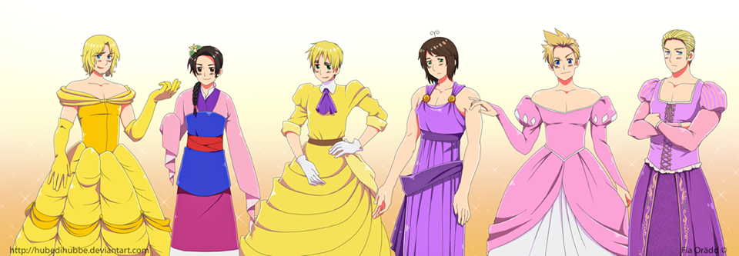
....................................................................................................
....................................................................................................
....................................................................................................
....................................................................................................
....................................................................................................
....................................................................................................
....................................................................................................
....................................................................................................
....................................................................................................
....................................................................................................
....................................................................................................
....................................................................................................
....................................................................................................
....................................................................................................
....................................................................................................
....................................................................................................
....................................................................................................

21. Ysgrifennwch lythyr caru gan blentyn 13 oed.
Geirfa berthnasol:

....................................................................................................
....................................................................................................
....................................................................................................
....................................................................................................
....................................................................................................
....................................................................................................
....................................................................................................
....................................................................................................
....................................................................................................
....................................................................................................
....................................................................................................
....................................................................................................
....................................................................................................
....................................................................................................
....................................................................................................
....................................................................................................
....................................................................................................

23. Pam mae’r cylchgrawn ‘Time’ wedi’ch dewis chi’n berson y flwyddyn?
Geirfa berthnasol:
haeddu
syndod
ymroddiad
....................................................................................................
....................................................................................................
....................................................................................................
....................................................................................................
....................................................................................................
....................................................................................................
....................................................................................................
....................................................................................................
....................................................................................................
....................................................................................................
....................................................................................................
....................................................................................................
....................................................................................................
....................................................................................................

